# Introduction

In these functions we cancel narrowband interference in a direct-sequence spread spectrum signal. The approach uses a two-sided transversal filter (see functional description below). The function relies on a second function to calculate the received signal correlation matrix and the current sample correlation vector. Currently the function works on a signal sampled at the chip rate. We believe that modification to allow cancellation on signals sampled more finely is possible, and are currently working on that modification. Some loss in SNR is possible if chip matched filtering and ideal sampling isn’t done prior to down-sampling.

## Features

* Accepts a complex vector of input samples (sampled at the chip rate) and outputs a vector of samples with NBI cancelled.
* Input also requires an estimate of Rxx and p (the correlation matrix and vector). These are estimated in CorrelationMatrixCalc.m
* CorrletionMatrixCacl.m accepts the complex samples and the filter length and outputs Rxx and p.

# Interface Description

## Generics

The function calls for the equalization approach are:

y = DsssNbiCancel(x, Rxx, p)

[Rxx, p] = CorrleationMatrixCalc(rx, FilterLength)

## Inputs

The function inputs to the functions are defined in Tables 1 and 2.

Table 1: Function Inputs – DssNbiCancel.m

|  |  |  |
| --- | --- | --- |
| Input Name | Type | Description |
| x |  | Vector of received samples – equal to the filter length |
| Rxx |  | Correlation matrix of input data |
| p |  | Current sample correlation vector |
|  |  |  |
|  |  |  |
|  |  |  |
|  |  |  |

Table 2: Function Inputs – Correlation MatrixCacl.m

|  |  |  |
| --- | --- | --- |
| Input Name | Type | Description |
| rx |  | Received signal samples (complex) containing the desired DS-SS signal and narrowband interference. |
| FilterLength |  | Length of the two-sided transversal filter |
|  |  |  |

## Outputs

The signal outputs from the above functions are defined in Tables 3 and 4.

Table 3: Function Outputs – DssNbiCancel.m

|  |  |  |
| --- | --- | --- |
| Output Name | Type | Description |
| y |  | Complex vector of received samples with narrowband interference removed |
|  |  |  |
|  |  |  |
|  |  |  |

Table 4: Function Outputs – Correlation MatrixCacl.m

|  |  |  |
| --- | --- | --- |
| Output Name | Type | Description |
| Rxx |  | N x N complex matrix representing the correlation matrix of the contents of the transversal filter (N is the length of the filter). |
| p |  | N x 1 complex vector representing the correlation between the current sample and the filter contents |

## File List

Table 5 lists the files provided with the functions.

Table 5: DSSS NBI Cancellation Source File List

|  |  |
| --- | --- |
| File Name | Description |
| CorrelationMatrixCalc.m | This function calculates the correlation matrix and correlation vector for use in a transversal filter which eliminates narrowband interference. |
| DsssNbiCancel.m | This function cancels narrowband interference from a DSSS signal using a two-sided transversal filter. The correlation matrix Rxx and correlation vector p are inputs. |
| TestDSSS.m | This script simulates narrowband tone interference and a BPSK modulated DSSS signal (random chipping) and applies the transversal filter to cancel the interference. The script also provides an example of how to call the function as well as allowing the system designer to test the function based on various interference parameters. |
|  |  |
|  |  |
|  |  |
|  |  |
|  |  |
|  |  |
|  |  |
|  |  |
|  |  |
|  |  |

# Functional Description

This technique is based on a classic linear tranversal filter shown in Figure 1. Specifically, it is assumed that the desired signal is uncorrelated from sample to sample, whereas the interference is correlated across the filter. The N/2 samples before and after the current sample are used to estimate the current sample and cancel it, under the assumption that the desired signal will appear uncorrelated (like noise) and will not be useful in cancelling the current sample. The NBI, however, since it is narrowband, it will be correlated from sample to sample and can be used to accurately predict interference signal in the current sample. The optimal filter weights (in the MMSE sense) are **w** = **Rxx**-1**p** where **Rxx** represents the correlation matrix of the filter contents and p represents the correlation between the current sample (i.e., the middle sample) and the filter contents.

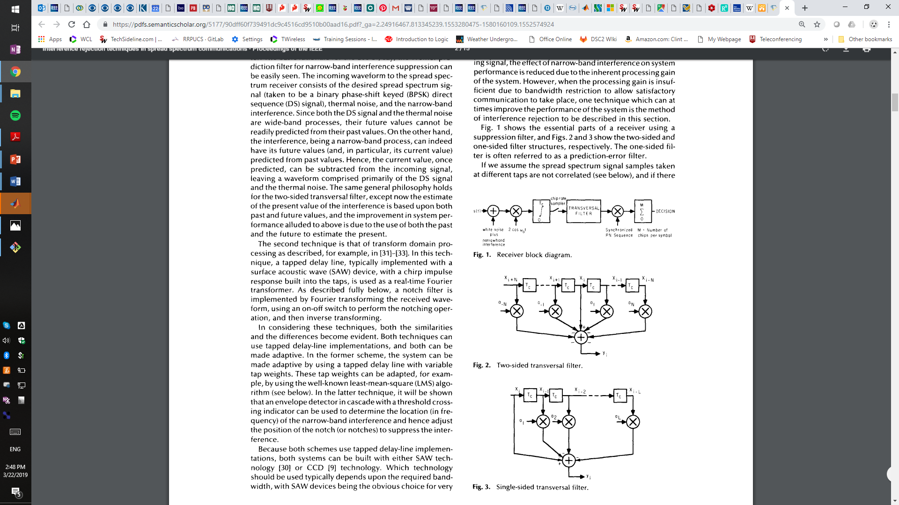

**Figure 1 – Two Sided Transversal Filter Structure Assumed**

The MMSE weights could also be found using one of two classic adaptive algorithms – the Least Mean Squares (LMS) algorithm or the Recursive Least Squares (RLS) algorithm. However, in our implementation we simply find the optimal weights directly using a block of samples.

Example Performance:

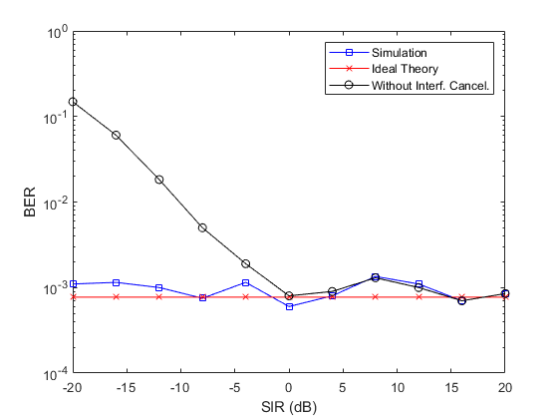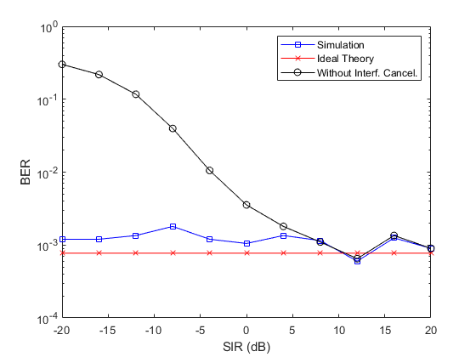

**Figure 2 - Performance of the transversal filter (length 20) approach versus SIR with SNR = 7dB, fI=0.0225 fs and spreading gain = 31 (left) and spreading gain = 7 (right)**

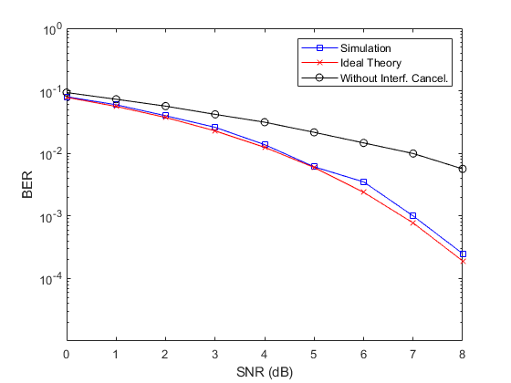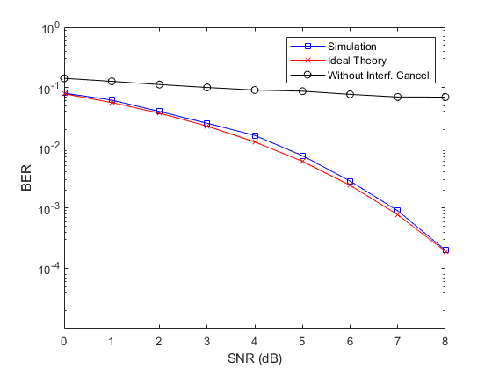

**Figure 3 - Performance of the transversal filter (length 20) approach versus SNR with SIR = -10dB, fI=0.0225 fs and spreading gain = 31 (left) and spreading gain = 7 (right)**

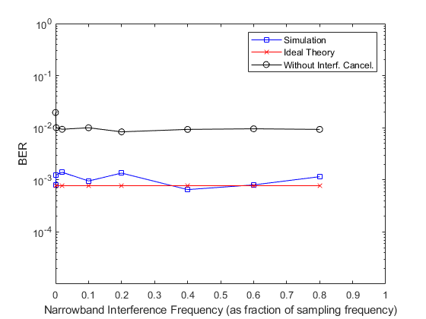 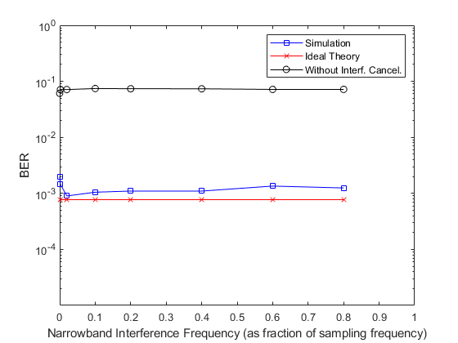

**Figure 4 - Performance of the transversal filter (length 20) approach versus Narrowband Interference Frequency (relative to sampling frequency fs) with SIR = -10dB, SNR = 7dB and spreading gain = 31 (left) and spreading gain = 7 (right)**